DAD 220

Ahmer Allauddin

Tanner Wale

17 May 2022

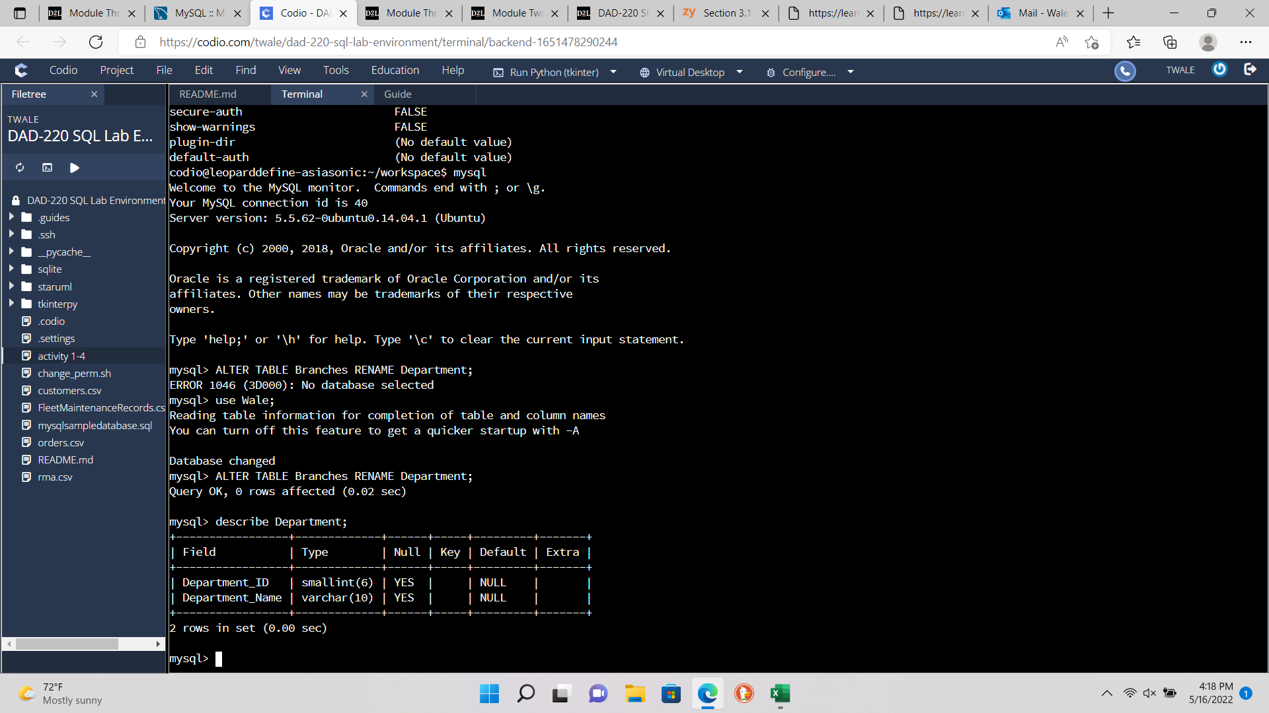

Renamed Branches table to Department table.

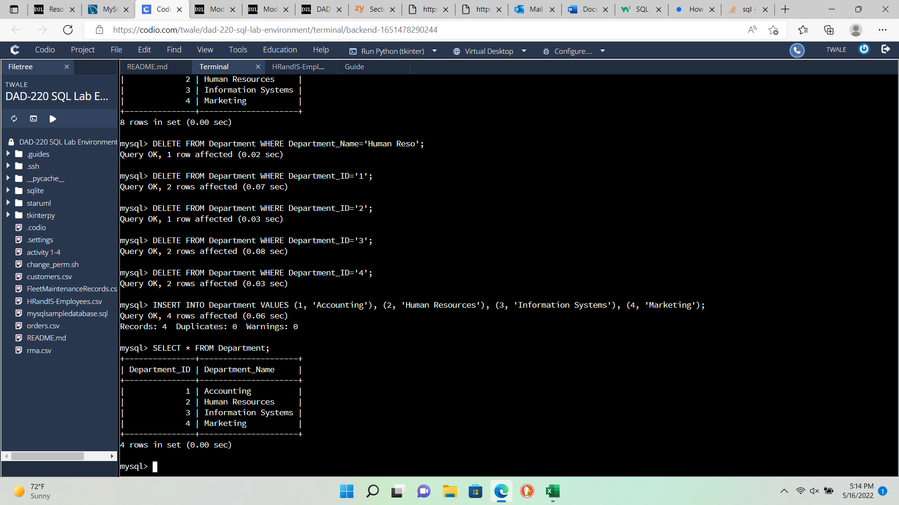

Adding Department_ID and Department_Name into the Department table.

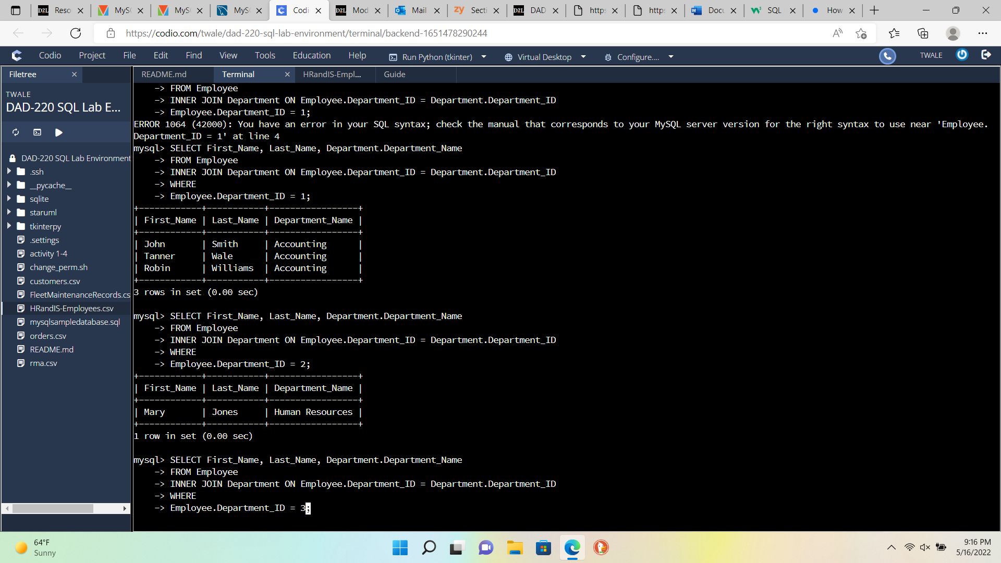

Old Employees being returned by using Employee.Department_ID.

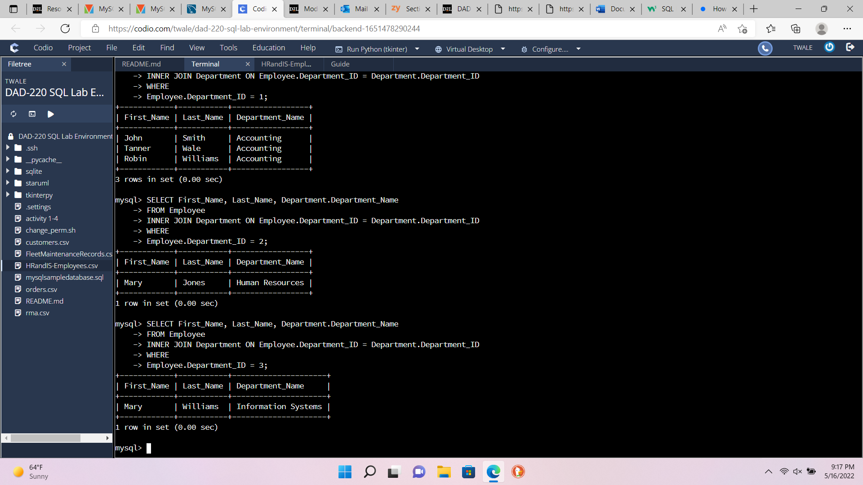

Old Employees being returned by using Employee.Department_ID.

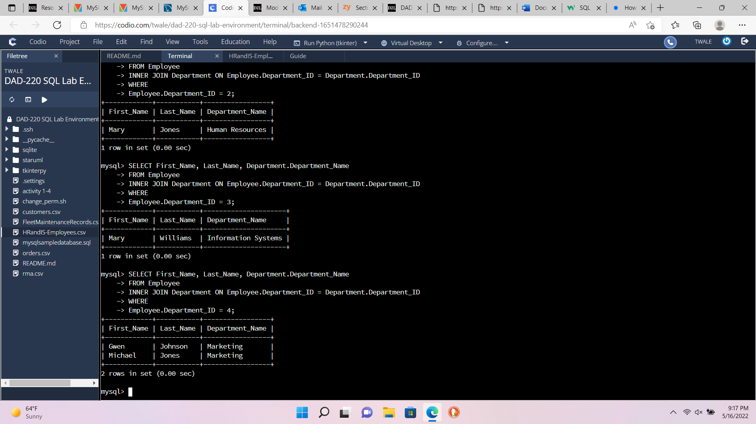

Joining tables using the INNER JOIN with specific Department_ID numbers for Accounting, Human Resources, Information Systems, and Marketing. Old Employees being returned by using Employee.Department_ID.

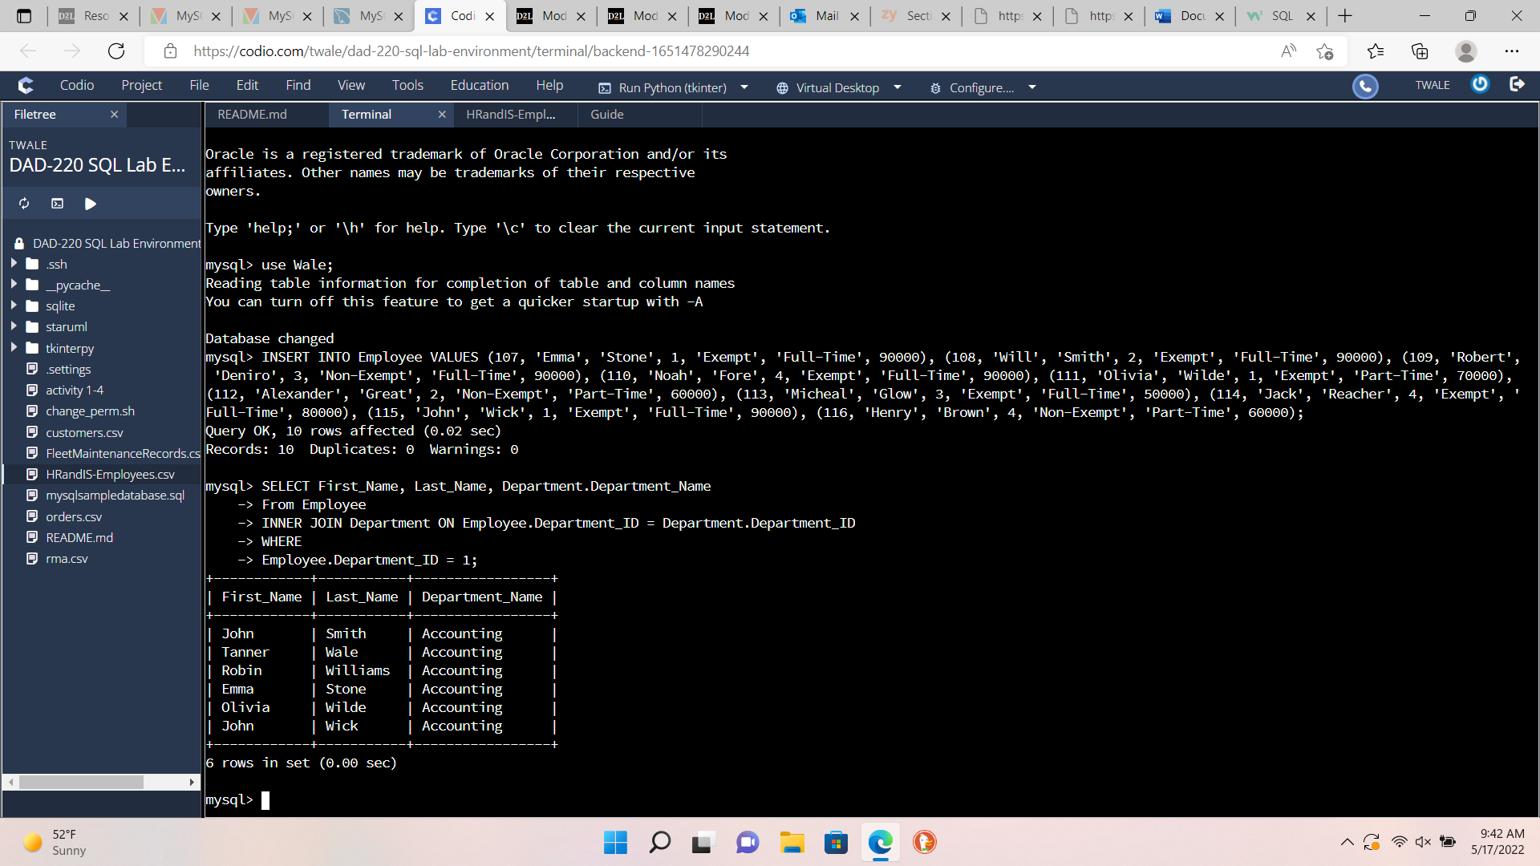

New Employees being added and returned by using Employee.Department_ID.

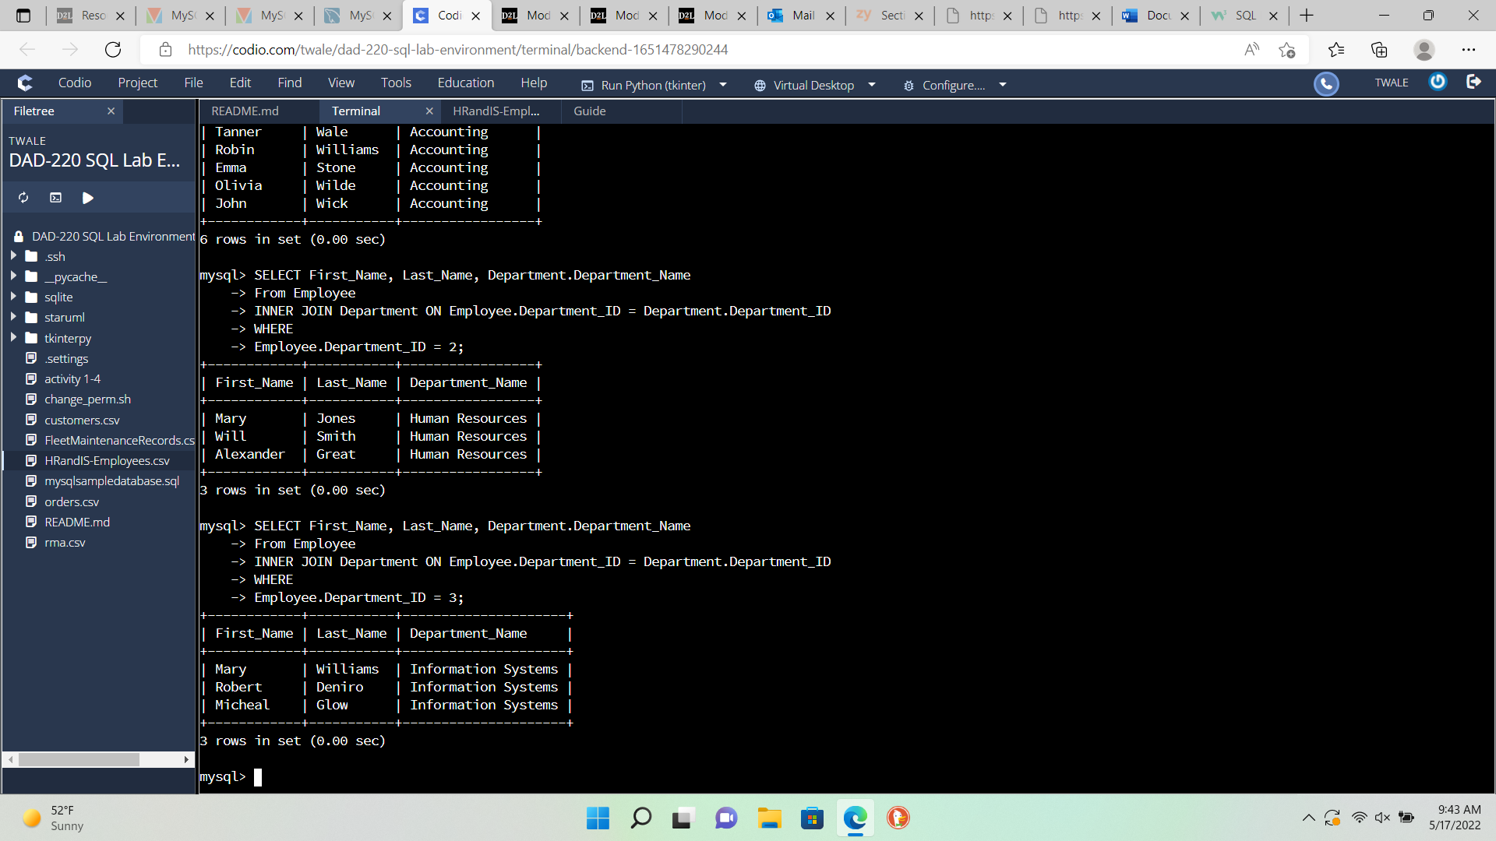

New Employees being returned by using Employee.Department_ID.

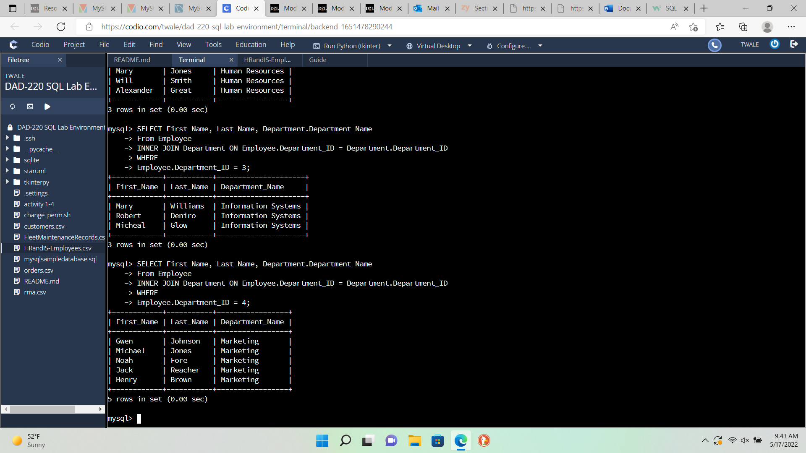

Outputting of new records after adding 10 new records including First name, Last Name, Employee_ID, Salary, Part-Time or Full-Time, and Non-Exempt or Exempt, and Depatment_ID. Which Department_ID gives them their Department_Name. In Accounting six employees are returned. In Human Resources three employees have been returned. In Information Systems three employees have been returned. In Marketing five employees have been returned. There were seven employees we added ten more employees and after returning all Department_IDs we have seventeen employees.

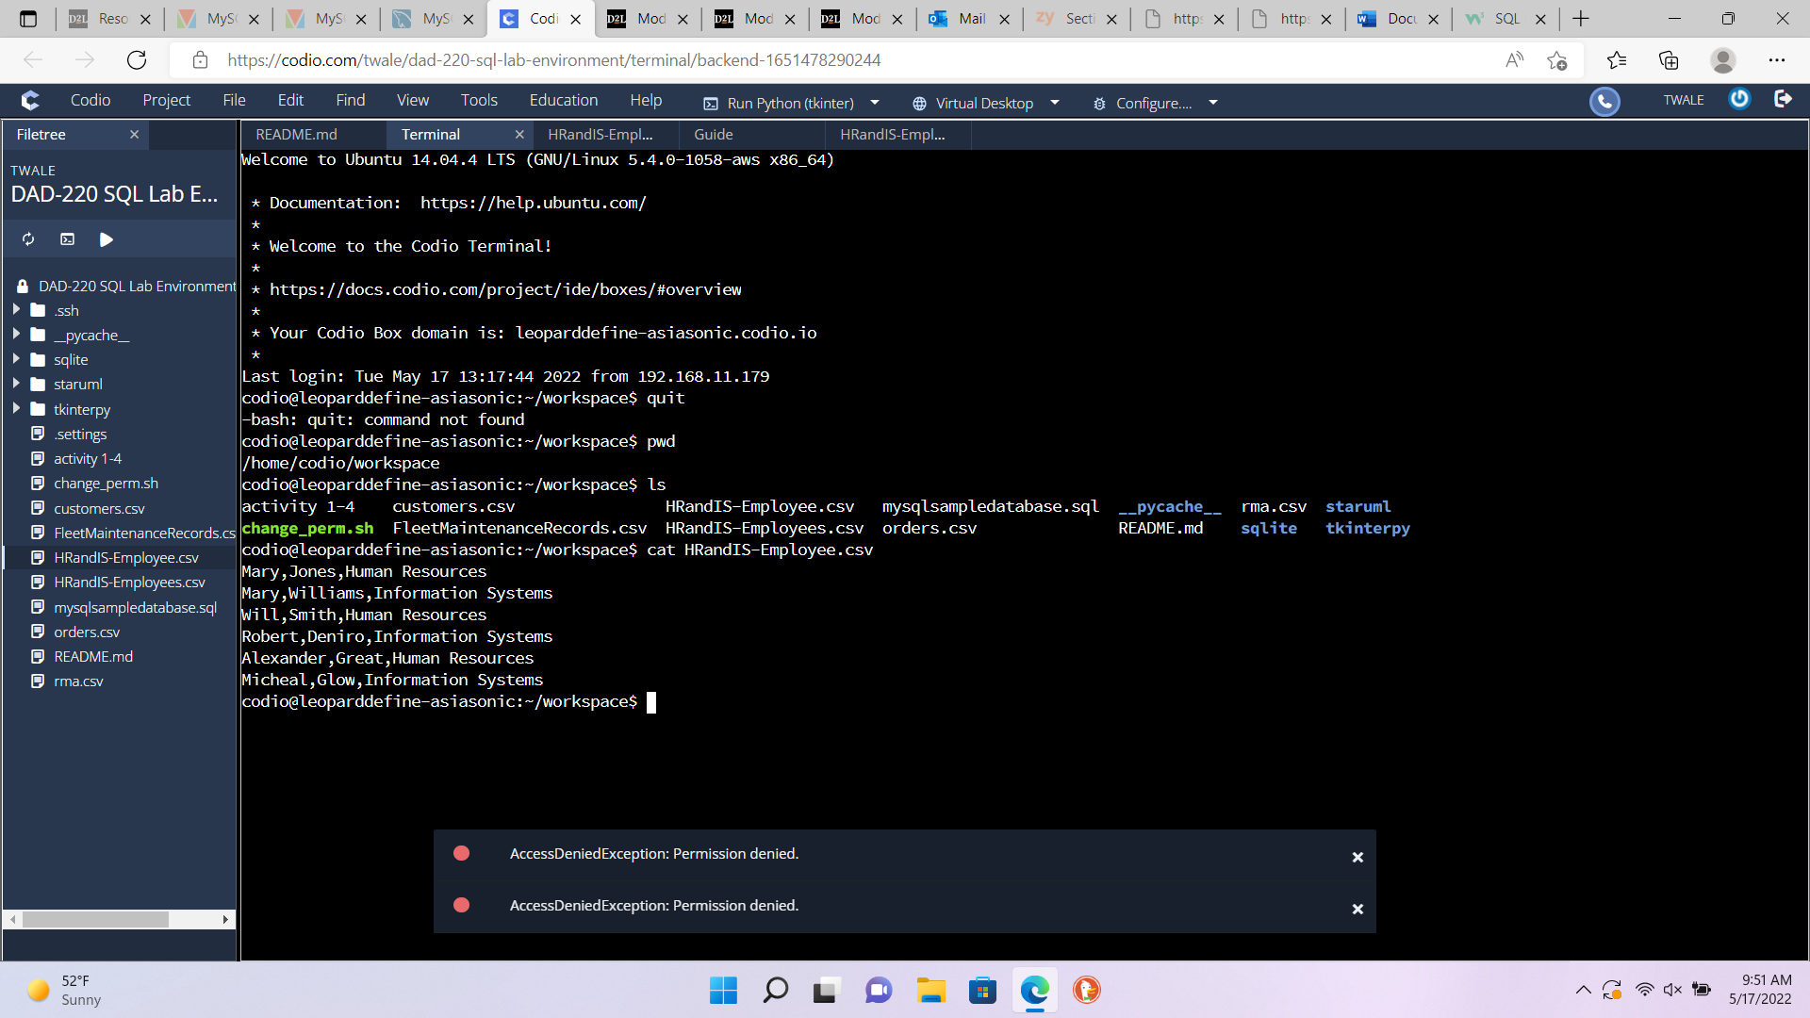

Outputting all Human Resources and Information Systems by using INNER JOIN, WHERE, Department_ID 2 OR 3.

1. **Explain** how **the joins** you used in this assignment worked.

We used the INNER JOIN to connect Employee.Department_ID equal to Department.Department_ID and specified using WHERE clause Employee.Department_ID = 1, 2, 3, or 4. The INNER JOIN connects the Employee table to the Department table by ID numbers.

**Describe** whythe **commands** you used were able to retrieve the Department table when you selected the Department name.

The commands used were SELECT Department.Department.Name. This SELECT statement first assigns the table it is looking for which is Department. Then, finds the attribute Department_Name.

1. **Identify** how many **records** are in the file when you write the records of your query to a CSV file.

There are six records in the CVS file after only certain Department_Name attribute Human Resources and Information Systems.

1. **Explain**, in detail, the process of **extracting data** to a flat file.

The process of extracting data to a flat file is first selecting the certain attributes you want to extract from the tables like First_Name, Last_Name, Department.Department_Name. Then, use the FROM command for specifying where you are getting the table from, in this case Employee. Then, use INNER JOIN to match Employee.Department_ID equal to Department.Department_ID. Then, specify WHERE or which Department_IDs you want to output to the CVS file. Finally, use INTO OUTFILE to output to a specific directory and the fields ended by commas ‘,’ and the data is formatted correctly by starting and ending First Name, Last Name, Department.Department_ID on different lines.